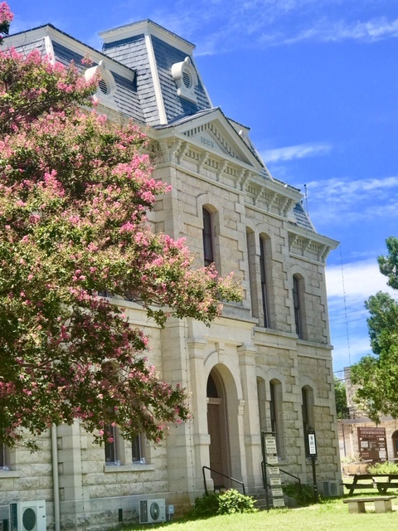
Greetings from the Old Blanco County Courthouse Preservation Society Board of Directors! During 2019, the Courthouse once again provided a venue for community events, weddings, parties, and meetings. The Visitor Center welcomed guests from Texas, the US, and countries around the world.
We continued our efforts to preserve and maintain our treasured building. This newsletter describes the projects that were completed and the ones that are currently underway.

News From The Old Blanco County courthouse Preservation Society

www.historicblanco.org info@historicblanco.org 830-833-2211
2014 What’s New

A membership application for OBCCPS is provided at the end of the newsletter. Please fill it out and return it to OBCCPS, or you can become a member or renew your membership at our website, www.historicblanco.org.

Window Restoration
We're pleased to report that we've undertaken the long-awaited window project. Hooray!! The windows have been taped for several years to prevent water infiltration. It's great to bid farewell to that unsightly tape.
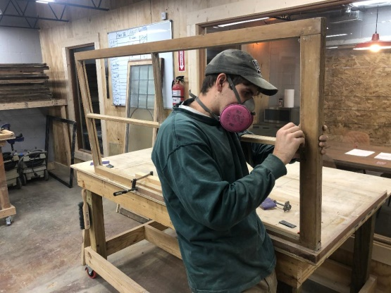
The Board hired John Hindman of Red River Restorations to complete the project. Hindman's process is to remove the sashes and take them to the company's factory in Austin. While the sashes are at the factory, the window openings in the building are covered with plywood. The jambs are examined at the Courthouse and any needed repairs are completed. At the factory, the paint is removed from the sashes using a steam process. Then needed repairs are completed, and the sashes are repainted on both the interior and exterior side and returned to the Courthouse. The upper sash is fixed in place, and the lower sash opens and closes. Additional parts of the project are replacing the sash cords and installing weather stripping.
Board member Paula Fowler coordinated the window project. She received the names of possible restoration companies from the Texas Historical Commission, sought bids from them, and handled communication between the board and Red River Restorations.
The project was funded with proceeds from the 2018 Capital Campaign (Thanks to everyone who contributed!) and income from the Gala and the sale of tax credits.
Floors Refinished
The first project of 2019 was to refinish the floors in the first floor hallway and large office and the second floor landings. After sanding, penetrating oil was used to finish the floors. Oil was chosen because minor damage from our many events can be more easily repaired with this type of finish. The work was completed by Bullet Flooring. Board member Mary Harris coordinated the project.

Cameras Installed
The Board voted to install cameras in the Courthouse. This is an attempt to identify responsibility for minor damage that we've experienced during events.

Landscaping
A landscaping project is anticipated for the Courthouse grounds. The project includes the following:
- creating a crushed granite area around the perimeter of the courthouse to help with drainage and protect the foundation of the Courthouse;
- repairing the granite paths by adding Sisterdale limestone edging and fabric underlayment to prevent weed intrusion;
- edging the planting beds to be installed on all four sides of the Courthouse with Sisterdale limestone;
- using native plants in the beds to add color and attract native birds and butterflies, consistent with the goal of water conservation;
- installing wooden screens painted to match the Courthouse stone to conceal exterior air conditioning units and trash cans;
- planting native Texas trees on the south and east side of the Courthouse along the perimeter of the grounds;
- rebuilding the dilapidated stone planter wall around the live oak trees at the southwest corner of the property and duplicating this same look near the northwest corner of the property;
- aerating the soil, which has been compressed over time from events and pedestrian traffic, and replanting grass as necessary; and
- repairing and enhancing the existing irrigation system to ensure even coverage and sustainability of the landscaping.
Property Medic has completed the screening, and Dennis Moore did the granite paths. Plants will be provided at cost by the Natural Gardener. Work on the project will continue as soon as all the needed permits have been obtained. The members of the Landscape Committee are Jeff and Sarah Harkinson, Hugo and Linda Mondragon, and Shirley Winslow.

2019 Gala
The 2019 Courthouse Gala, Una Noche en Viejo Blanco, was enjoyed by over two hundred guests. The evening began with a mariachi band, hors d’oeuvres, beer, and wine. The dinner was catered by Verde’s Mexican Parrilla restaurant. Entertainment during and after dinner was provided by the Lost Sounds. Mary Harris chaired this year’s successful and enjoyable Gala.
OBCCPS 2020 Annual Meeting
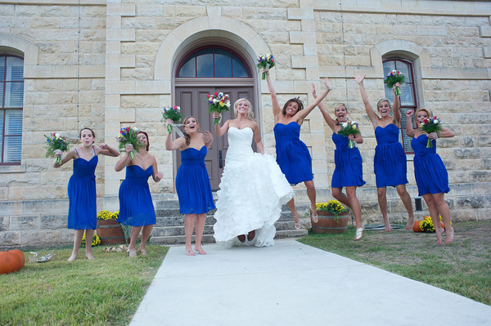
The annual meeting of the Old Blanco Courthouse Preservation Society will be held March 12, 2020. The evening will begin at 6:30 PM with a wine and cheese social, followed by the meeting at 7:00 PM. The public as well as OBCCPS members are invited to attend.
;

Thank You

Gala Committee and Contributors: Thank you to everyone who helped put together another successful Gala. The members of the Gala Committee were Mary Harris, Chair; Trey Atchley; Jan Brieger; David Widaki; Mike Brady; Karen Knutson; Debra DuPont; Paula Hollingsworth Fowler; Margie Dyer; Jim Harris; Lesley Griffin; Dawn Forsburg; and Todd Rogers. Jeff Harkinson and Mabel Rollins organized the Texas Hold ‘Em Poker Tournament. Verde's Mexican Parilla restaurant catered the dinner. Judith Raven of Esperanza Winery in Blanco donated all the wine, and Real Ale Brewing Company donated the beer. Boy Scout Troop # 497 helped with set up and clean up. Several businesses and individuals donated to the silent and live auctions. Volunteers helped with a variety of tasks before, during, and after the Gala. Thanks to everyone who donated and volunteered!
Capital Campaign Donors: Thank you to the businesses and individuals that so generously contributed to the OBCCPS Capital Campaign.
Courthouse Volunteers: Thank you to the volunteers that assist Lesley Griffin during busy times and help keep the Visitor Center open seven days a week. Volunteers during 2019 were Erika Fickle, Joanne Marshall, Dora Weaner, Judy Gaines, and Margie Dyer.
Manager Lesley Griffin: Thank you to Lesley for her work as Courthouse manager. All of the renovations make the job a lot more challenging, but Lesley doesn't disappoint.
OBCCPS Members: Thank you to the members of OBCCPS for the contribution you make as members of the Society.
Photos: First page top photo, Lesley Griffin; first page bottom, John Hindman;
2019 OBCCPS Board of Directors: Jim Harris, President; Jan Brieger, Vice President; Margie Dyer, Secretary; Barry Pierce, Treasurer; and members Trey Atchley, Doug Dowlearn, Debra DuPont, Paula Hollingsworth Fowler, Jeff Harkinson, Mary Harris, Karen Knutson, and Todd Rogers.
2020 Membership Application
Individual Membership Couple Membership
_____ Annual ($20) _____ Annual ($40)
_____ Lifetime ($500) _____ Lifetime ($1000)
Organization/Business Membership
_____ Annual ($100)
Name(s) ___________________________________________________________________________

Mailing Address ____________________________________________________________________

Telephone _____________________________ Email _______________________________

Return form to OBCCPS, PO Box 302, Blanco, Texas 78606-0302

Old Blanco County Courthouse Preservation Society
PO Box 302
Blanco, TX 78606

